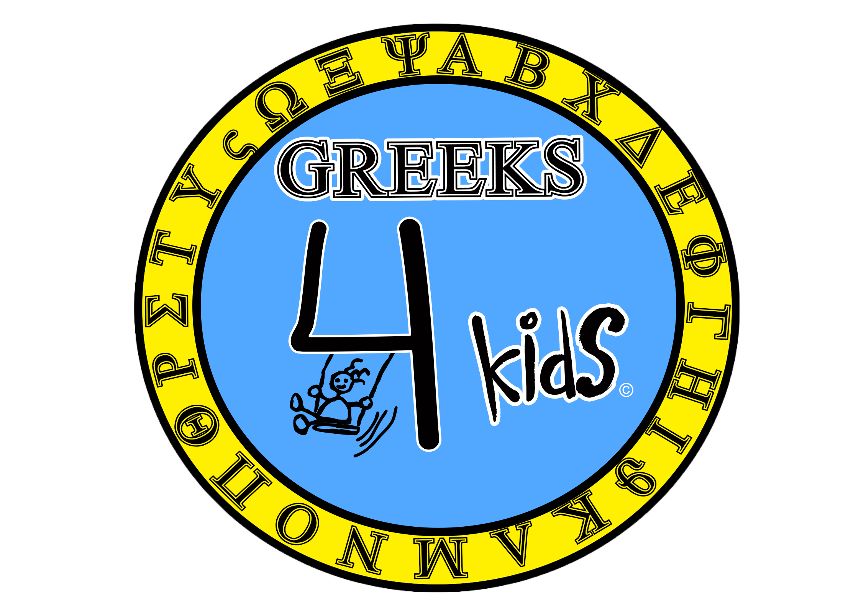
Greeks 4 Kids
A California Non-profit Public Benefit Corporation

Nonprofit 501(c)(3) Narrative Description of Activities

It is the mission of Greeks 4 Kids to provide provisions for impoverished, homeless and ill children on a local and global level, with an emphasis on the most underprivileged areas of California.

It is our sole duty to provide amenities for young children who are enduring terrifying tribulations in their life, and also create a more positive and nurturing environment for them to thrive in. Greeks 4 Kids firmly believes that young people are the future of our nation and that it is essential to provide children living in hospitals or shelters with the tools they need to help them succeed and grow into maturity as a functioning and industrious adult. These tools include, but are not limited to, school supplies, toys, backpacks, clothing, books and hospital equipment.

Fundraising

Greeks 4 Kids raises funds both by holding philanthropic events such as volleyball tournaments and clothing drives on various college campuses as well as to increase student involvement and awareness of the plight of the underprivileged youth. We will use the entirety of our time and these raised funds to purchase physical goods (school supplies, toys, backpacks, clothing, books and hospital equipment) and donate them to other 501(c)(3) entities such as hospitals and children’s centers.

Distribution

Greeks 4 Kids does not raise funds for any specific individual or single organization. We intend to donate to a plethora of organizations, mostly 501(c)(3), that share a similar mission and will further our exempt status, with the objective to aid children in need of the basic amenities they require in the midst of tribulations such as sickness and monetary struggles in the form of school supplies, toys, books, clothing, etc.

One example of an organization which we may contribute to is “Children’s Hospital Los Angeles” (EIN: 95-1690977) which is a United States-based, nonprofit, non-partisan 501(c)(3) tax exempt organization that shares a similar mission to ours and focuses on providing aid to extremely ill children from all around the world with an emphasis on women in the Southern California area.

Greeks 4 Kids may exercise its right under law to contribute to non 501(c)(3) organizations only on the condition that Greeks 4 Kids retains control over the use of the funds and maintains records and documentation showing that the funds are used exclusively for charitable purposes in accordance to our mission.

Programs for volunteers

At the discretion of the board of directors, we may provide internships or volunteer opportunities so that larger projects may be handled in an effective and professional fashion to grow and improve our events. Some activities that our volunteers may be involved in include: packing backpacks with supplies for underprivileged students, handing out clothing to the less fortunate, assisting in the process of creating a philanthropic event on a college campus, and donating toys to local hospitals. All activities will always be free of charge and will never include compensation to volunteers.

Awareness

It is our goal to raise awareness about the plight of children living under harsh conditions and we will be using many outlets, especially social media, to increase this awareness. This does not exclude the creation of documentaries, slideshows, pamphlets and other physical forms of advertisement for our organization. The purpose of documenting our organization is to broaden our outreach and ultimately increase the amount of children to which we can provide aid.

Financial information

The sources of the corporation’s income derive from personal resources and public donations. Additional income sources will include grants, sponsorship and fundraising. The corporation disposes its income through the decisions made by its board of directors or through the decisions of the duly elected treasurer, whose power to pay expenses is set out by the board or the corporation’s bylaws in accordance to the corporation’s purpose. We will not be using any income to provide a salary for our board of directors or any other members of our organization. Expenses paid by the corporation include, but are not limited to: the purchase of toys, books, games, school supplies, hospital equipment, backpacks, etc.

Please Note:

- Section 1.501(c)(3)-1(d)(2) of the Income Tax Regulations states that the term “charitable is used in its generally accepted legal sense, which includes “Relief of the poor and distressed or of the underprivileged,” which abides with the mission of Greeks 4 Kids.
- Section 501(c)(3) of the Internal Revenue Code provides tax exemption for organizations organized and operated exclusively for charitable and/or educational purposes.

